**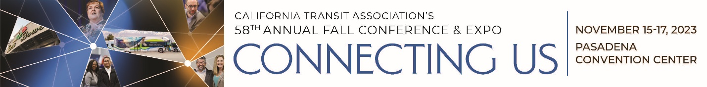  
  
58th Annual Fall Conference  
Agenda-at-a-Glance**(Pasadena Convention Center)

**Wednesday, November 15**

7:00 a.m. – 5:30 p.m. Registration Desk Open

9:30 a.m. – 10:45 a.m. Welcome & Opening Keynote Presentation

11:00 a.m. – 12:15 p.m. Concurrent Sessions I

12:30 p.m. – 2:00 p.m. Lunch and Expo

2:15 p.m. – 3:30 p.m. Concurrent Sessions II

3:45 p.m. – 5:00 p.m. Technical Workshop

5:00 p.m. – 7:00 p.m. Welcome Reception and Expo

**Thursday, November 16**

7:00 a.m. – 5:00 p.m. Registration Desk Open

7:30 a.m. – 9:00 a.m. Small Operators Award Breakfast  
 (Separate Registration Required)

7:30 a.m. – 9:00 a.m. Breakfast and Expo

9:15 a.m. – 10:30 a.m. General Session

10:45 a.m. – 12:00 p.m. Concurrent Sessions III

12:00 p.m. – 2:30 p.m. Lunch and Expo

2:45 p.m. – 4:00 p.m. Concurrent Sessions IV

5:00 p.m. – 7:30 p.m. Evening Reception

**Friday, November 17**

7:30 a.m. – 10:00 a.m. Registration Desk Open

7:30 am – 8:30 am Networking Breakfast

8:45 a.m. – 10:00 a.m. Closing Keynote

10:00 a.m. – 10:15 a.m. Closing Remarks & Grand Prize Drawing

10:15 a.m. Conference Adjourns

10:30 a.m. – 1:00 p.m. Local Tours

*The Expo Hall will be open during the conference hours on Wednesday and Thursday with dedicated time both days.